|  |  |
| --- | --- |
| **C:\Documents and Settings\Bala\Desktop\logo.jpg** | **ST.ANNE’S**  **COLLEGE OF ENGINEERING AND TECHNOLOGY**  (Approved by AICTE New Delhi, Affiliated to Anna University, Chennai)  (An ISO 9001:2015 Certified Institution)  ANGUCHETTYPLAYAM, PANRUTI – 607 106. |

**QUESTIONS BANK**

**CS6503-THEORY OF COMPUTATION**

**UNIT-1**

**FINITE AUTOMATA**

PART-A

1. What is a finite automaton? (Nov/Dec 2015)
2. What are the Applications of Automata theory? [May – 2008]
3. What is Induction principle? Give an example. [NOV/DEC 2012 ]
4. Draw a non-deterministic automata to accept strings containing the substring 0101. (may- 2016)
5. State the pumping lemma for regular languages. (may/June 2016)
6. Write Regular Expression for the set of strings over {0,1} that have atleast one.(NOV/DEC-2015)
7. What is meant by DFA? [MAY/JUNE 2013]
8. What is a Non-Deterministic Finite Automaton (NDFA)? (Nov/Dec 2013)
9. Obtain the  closure of states q0 and q1 in the following NFA with  transition?[Dec 2014]



1. Define NFA with ε transition. [MAY/JUNE 2013] [APR/MAY 2018]
2. Difference between DFA and NFA.
3. What is a Regular Expression? [NOV/DEC 2012].
4. What are the applications of pumping lemma? [NOV/DEC 2007]
5. Construct a DFA for the regular expression aa*bb*.
6. What is {10,11}*?
7. Construct NFA for regular expression a*b*.
8. Construct a DFA that will accept strings on {a,b} where the number of b’s divisible by 3.
9. Differentiate L* and L+ .
10. Construct the DFA that accepts input string of 0’s and 1’s not containing 101 as substring. [APR/MAY 2018]
11. Differentiate regular expression and regular language.

PART-B

**1.**Explain inductive proof with example.(13)

**2.**Write about the various form of proof.(7)

3. Prove that “A language L is accepted by some DFA if and only if L is accepted by some

NFA”(13)

4. consider the following ε-NFA for an identifier. Consider the ε-closure of each state and find

it’s equivalent DFA.(13) or (14)

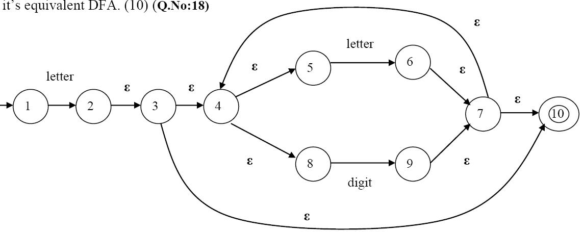

5.convert the given NFA to DFA.(13)

|  |  |  |
| --- | --- | --- |
| state/input | 0 | 1 |
| q0 | {q0,q1} | q0 |
| q1 | q2 | q1 |
| q2 | q3 | q3 |
| *q3 | φ | q2 |

6.Write any one example for NFA-ε to NFA without ε.(6)

7.Construct the minimal DFA for the regular expression ( b \ a)*baa.(13).

8.Write and explain the algorithm for minimization of a DFA. Using the above algorithm

minimize the following DFA. (May/June 2016)(14)

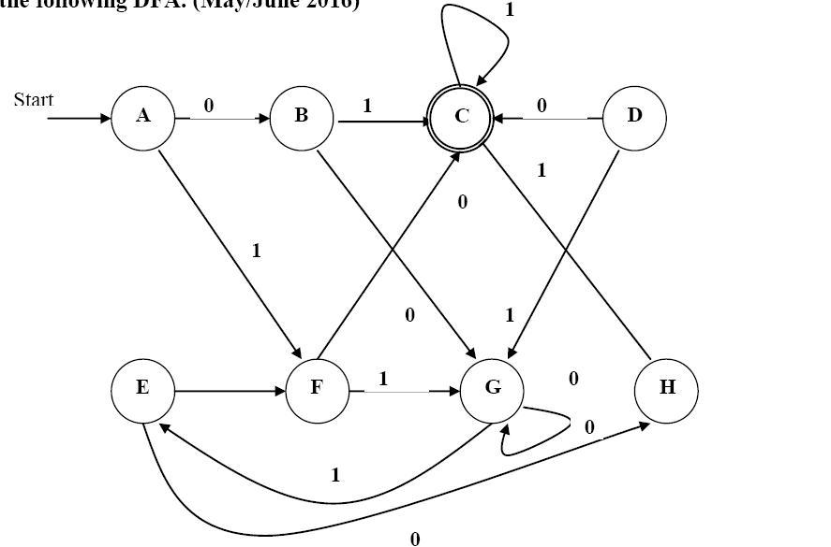

9.State pumping lemma with example.(13)

10.Describe the closure properties of regular languages. [APR/MAY 2018]

11.Determine DFA from a given NFA

M = ({q0,q1},{0,1},δ,q0,{q1})where is given by

δ (qo,0)={q0,q},δ (q0,1)={q1},δ (q1,0)=φ, δ(q1,1)=q0,q1} [APR/MAY 2018]

**UNIT-II**

**GRAMMERS**

**PART-A**

1.Define a Context Free Grammar. [**May/June 2010**]

2.What are the applications of Context free languages? [**Dec 2009**]

3.What is: (a) Derivation (b) Sub tree.

4.What is an ambiguous grammar? [**Dec 2009**]

5.Construct the grammar for the language L= { anban | n>=1}.

6.Construct the context-free grammar representing the set of palindromes over (0+1)* (Nov/Dec 2015)

7.Let the productions of a grammar be S →0B, A→0/0S/1AA, B→1/1S/0BB. For the string 0110 find a right most derivation. [**MAY/JUNE 2007**]

8.Construct a context free grammar for generating the language L = {anbn | n≥1}

(Nov/Dec-2004, 2010, 2013, May-05, 06)

9.Convert the following grammar into an equivalent one with no unit productions and no useless symbols S→ABA, A→ aAA | aBC | bB, B→A | bB | Cb, C→CC | cC .

(Nov/Dec 2011)

10.When a grammar is said to be ambiguous? (May 2013) [APR/MAY 2018]

11.Consider the following grammar G with productions ( May 2010)

S→ABC | BaB

A→ aA | BaC | aaa

B→ bBb | a

C→ CA | AC.

12.Let G be the grammar S→aB|bA, A→a|aS|bAA, B→b|b|S|aBB. For the string aaabbabbba find a leftmost derivation.(May/June’07)(Apr/May‘08)(Nov/Dec 2015)

13.What do you mean by null production and unit production? Give an example.

14.Construct a CFG for set of strings that contain equal number of a’s and b’s over Σ={a,b} (May/June 2016)

15. What is meant by left and right sentential form?

16. Find the grammar for the language L = {a2nbc, where n>1}

17. Find the language generated by a CFG. G = ( {S}, {0 , 1}, { S→0/1/є, S→0S0/1S1/S} )

18. Define Chomsky Normal Form? [APR/MAY 2018]

19. Derive the rules to remove Є productions with an suitable example (Dec’09)

20. Find the grammar for the language L = {a2nbc, where n>1}

**PART-B**

1) Derive the strings a*(a+b00) using leftmost and rightmost derivation for the following

production.(8)

1. E→I

2. E→E+E

3. E→E*E

4. E→(E)

5. I→a

6. I→b

7. I→Ia

8. I→Ib

9. I→I0

10.I→I1

2. Show that the grammar S→aSbS | bSaS | e is ambiguous and what is the language

generated by this grammar? (Nov/Dec 2006)(8)

3. The following grammar generates the language of Regular expression 0*1(0+1)*.

S→A1B

A→0A | Є

B→0B | 1B | Є

Give leftmost and rightmost derivations of the following strings

00101 b) 1001 c) 00011 (May/June 2006) (16)

4. Given the grammar G = (V,Σ,R,E), where

V={E,D,1,2,3,4,5,6,7,8,9,0,+,-,*,/,(,) }

Σ={1,2,3,4,5,6,7,8,9,0,+,-,*,/,(,) }, and R contains the following rules:

E→D | (E) | E+E | E-E | E*E \ E | E

D→0 | 1 | 2 |…..9

Find a parse tree for the string 1+2*3. (6) (Nov/Dec 2015) (16)

5. Let G be the grammar S→0B|1A, A→0|0S|1AA, B→1|1S|0BB.

For the string 00110101 find (Apr/May 2004) (May/Jun2007)(8)

6. Find the language L(G) generated by the grammar G with variables S, A, B terminals a, b and productions S→aB, B→b, B→bA, A→aB.(8)

7. If G is a grammar S→SbS | a prove that G is ambiguous (Apr/May 2004)(8)

8. Show that the grammar S →a | Sa | bSS | SSb | SbS is ambiguous (8) (Nov/Dec2007)

9. Find a derivation tree of a*b+a*b given that a*b+a*b is in L(G) where G is given by S→S+S/S*S/a/b (May/June 2007).(8)

10. Let G=(V,T,P,S)be a Context free Grammar then prove that if the recursive inference procedure tells us that terminal string W is in the language of variable A, then there is a parse tree with root A and yields w. (Nov/Dec 2015)(16)

11. Begin with the grammar

S→ASB/ε

A→aAS/a

B→SbS/A/bb

(a) Are there any useless symbols? Eliminate them

(b) Eliminate ε productions

(c) Eliminate unit productions

(d) Put the grammar into Chomsky normal form. (Nov/Dec 2015)(16) [APR/MAY 2018]

12. Find the CNF for the following grammar,

S→aB/bA

A→aS/bAA/a

B→bS/aBB/b. (Nov/Dec 2005) (Nov/Dec 2006)

13. What is the purpose of normalization? Construct the CNF and GNF for the following grammar and explain the steps. [APR/MAY 2018]

S→aAa | bBb | Є

A→C | a

B→C | b

C→CDE | Є

D→A | B | ab (May/June 2016).

14. Convert the following grammar to GNF

S→AB

A→BS/b

B→SA/a.

**UNIT-3**

PUSH DOWN AUTOMATA

**PART-A**

1. Define Pushdown Automata. (May/June 2016)
2. What are the different types of language acceptances by a PDA and define them. (Nov/Dec 2015)
3. Define Deterministic PDA. [APR/MAY 2018]
4. Define Instantaneous description (ID) in PDA. (MAY-06/09)
5. How do you convert CFG to a PDA.
6. State the pumping lemma for CFLs.(May-08)
7. Convert the following CFG to a PDA (Nov/Dec 2015)
   * 1. S→aAA, A→aS | bS | a
8. Does a pushdown Automata has memory? Justify. (May/June 2016)
9. Give an example of PDA.(DEC-05)
10. Is the language of DPDA and NPDA same? (MAY-06/09)
11. Define the languages generated by a PDA using the Two methods of accepting a language.(May-07)
12. Construct a PDA to accept a language {(an)n|n>=1} by empty stack.(Dec-09)
13. Compare NFA and PDA.(Dec-13)
14. Draw the symbols used in PDA.
15. Design PDA for the language L={001}
16. Design PDA for the language L={0011}
17. Define NDPDA.
18. What are the ways of language acceptance in PDA. [APR/MAY 2018].
19. Design DPDA for L=anbn where n>=1.
20. Write algorithm for getting production rule of CFG.

**PART-B**

INSTANTANEOUS DESCRIPTION:

1.Design PDA to accept the language L={wcwR / w={0,1}*}(8) [APR/MAY 2018]

2.Design PDA for the language L = {anb2n | n ≥0 } (Nov/Dec 2008) (8)

3.Construct a transition table for PDA which accepts the Language L= { a3nbn | n ≥ 0 } (16)

4.Design a PDA to accept {0n 1n | n≥1}.Draw the transition diagram for the PDA. Show by instantaneous description that the PDA accepts the string ‘0011’. (10) (Nov/Dec 2015)(8)

5.Construct a pushdown automaton to accept the following language L on Σ = {a, b} by empty stack L= { wwR | w Є Σ +} (May/June 2016)(8)

Problems for converting PDA to CFG:

6.Convert the PDA P = ({q, P}, {0, 1},{X,Z0},δ,q,z0) to a CFG if δ is given by

(a) δ(q,1,z0) = {(q,Xz0)}

(b) δ(q,1,X) = {(q,XX)}

(c) δ(q,0,X) = { (P,X)}

(d) δ(q,ε,X) = {(q,ε)}

(e) δ(P,1,X) = {(P,ε)}

(f) δ(P,0,z0) = {(q,z0)} (16)

7.Construct CFG for the following PDA where δ is given by,

P=({q0,q1},{0,1},{X,Z0},δ,q,z0,Ф)

(a) δ(q0,0,z0) = { (q0,Xz0)}

(b) δ(q0,0,X) = { (q0,XX)}

(c) δ(q0,1,X) = { (q1,ε )} (8) [APR/MAY 2018]

8.Convert PDA to CFG. PDA is given by P = ({p, q},{0,1},{X,Z},δ, q, Z), δ is defined by

δ(p,1,Z)={(p, XZ)},

δ(p,Є,Z)={(p, Є)},

δ(p,1,X)={(p, XX)},

δ(q,1,X)={(q, Є)},

δ(p,0,X)={(q, X)},

δ(q,0,Z)={(p, Z)}, (Nov/Dec 2015) (16)

Converting CFG To PDA

9.Construct the PDA for the following grammar E →E+E | E * E | a (8)

10.Consider the grammar G=(V,T,P,S) when S → aA, A → aABC/bB/a, B →b, C→c and find the PDA.(8)

11.Construct the CFG for L = { 0n10 n | n ≥ 0} and use it to construct PDA.(8)

DETERMINISTIC PUSHDOWN AUTOMATA

12.What are deterministic PDA’s? Give example for Non-deterministic and deterministic PDA? (8) (Nov/Dec 2015)

PROBLEMS ON PUMPING LEMMA

13.State pumping Lemma for CFL. Use pumping lemma to show that the language

L = { aibjck | i<j<k} is not a CFL. (8) [APR/MAY 2018]

14.Show that the language L = { anbncn /n ≥ 0} is not a context free language.(8) [APR/MAY 2018]

**UNIT-4**

**TURING MACHINE**

PART-A

1. What is a Turing Machine?(MAY/JUNE-16) [APR/MAY 2018]
2. What is a multitape Turing machine?(NOV/DEC-15)
3. Write about the chomskian hierarchy of languages.(APR/MAY-17) [APR/MAY 2018]
4. What is halting problem?(APR/MAY-17)
5. Define instantaneous description and move of a turing machine.
6. what are the features of universal turing machine?
7. What is meant by multihead turing machine?
8. What are the applications of Turing machine? (Dec-12)
9. List out techniques for Turing machine construction.(Dec -13)
10. What are the possibilities of a TM when processing an input string?
11. What are the techniques for Turing machine construction?
12. Differentiate Multitape and Multitrack machines.(Dec-08)
13. When is checking off symbols used in TM?
14. What is a 2-way infinite tape TM?
15. What are the reasons for a TM not accepting its input?
16. Construct a Turing machine to compute ‘n mod 2’ where n is represented in the tape in

unary form consisting of only 0’s. (May – 11)

1. Design a Turing machine with not more than states that accepts languages a (a+b)* .

Assume Σ = {a, b}(May-05).

1. What are the Comparison of FM, PDA and TM?
2. Define Power of turing Machine.
3. What are the differences between a finite automata and a Turing machine?(APR/MAY-16)

**PART-B**

**TURING MACHINE**

1.Explain the programming techniques for Turing Machine construction. (14)(Nov/ Dec-12)(13)

2.Explain briefly about Two way Turing Machine.(7) (May/June-04,05, Nov/Dec-05,08,09,12,13)

**COMPUTATIONAL LANGUAGES AND FUNCTIONS**

3.Construct TM for the language L = {an bn } where n≥1. (May – 09)(7)

4.Construct a TM for L = {1n0n1n / n≥0 }.(May – 12)(6)

5.Construct TM for performing subtraction of two unary numbers f(a-b) = c where a is

always greater than b.(Dec -03,Dec – 05,May -11)(7)

**TWO WAY TURING MACHINE**

6.Construct a TM for a language having equal number of a’s and b’s.(7)

7.Construct a TM for a language obtaining two’s complement of a binary number.(7)

8.Construct a TM for reversing a binary string on the input tape.(6)

9.Build a multitrack turing machine for checking whether given number is prime or not?(7)

10.Design a turing machine which reverses the given string{abb}.(6) [APR/MAY 2018]

**TYPES OF TURING MACHINE**

11.Explain about Types of Turing machine.(7)

**HALTING PROBLEM**

12.Explain Halting problem. Is it solvable or unsolvable problem? Discuss.(13) (May/June-16)

**CHOMSKY HIERARCHY OF LANGUAGES**

13.Explain about the Chomsky hierarchy of languages.(DEC-15)(7)

14.construct Turing machine perform unary multiplication. [APR/MAY 2018]

**UNIT-5**

**UNSOLVABLE PROBLEMS AND COMPUTABLE FUNCTIONS**

PART-A

1. When a problem is said to be decidable and give an example of undecidable problem.

(Nov/Dec 2015)

2. Show that the complement of a recursive language is recursive.(Dec-04,may-05)

3. Give two properties of Recursively Enumerable Sets which are undecidable.

4. When a language is said to be recursive? Is it true that every regular set is not

recursive?(Nov/Dec -05)

5. Differentiate between recursive and recursively enumerable languages.(Apr/May-07)

6. When do you say a problem is NP-hard?(Dec-09)

7. Mention the difference between P and NP problems.

8. What is recursively enumerable? (May-12,Nov/Dec-13) [APR/MAY 2018]

9. Show the union of recursive language is recursive.

10. What are a) Recursively Enumerable b) Recursive sets? (Nov/Dec-13)

11. Define the class NP problem.(Nov/Dec-13)

12. What do you mean by universal turing machine?(Nov/Dec-05,13)

13. Define the classes P and NP problems. (May-14)

14. When a recursively enumerable language is said to be recursive? Is it true that the

language accepted by a non-deterministic Turing machine is different from recursively

enumerable language? (May/June 2016)

15. What are the different types of grammars/languages?

16. Define PCP or Post Correspondence Problem?

17. Define MPCP or Modified PCP.

18. What is a universal language Lu? (Nov/Dec 2015) [APR/MAY 2018]

19. Define Rice Theorem?

20. What is primitive recursive function?(May-2017)

**PART-B**

1. (i) Prove that “MPCP reduces to PCP”. (10) (**Nov/Dec 2015)**

(ii) Discuss about the tractable and intractable problems. (6) ( **Nov/Dec 2015)**

2. (i) State and explain RICE theorem. (10) (**Nov/Dec 2015)**

(ii) Describe about Recursive and Recursively Enumerable languages with examples. (6)

3. What is a universal Turing machine? Bring out its significance. Also construct a Turing

machine to add two numbers and encode it. (16) **(May/June 2016)**

4. What is a post corresponding problem (PCP)? Explain with the help of an example.(10) **(May/June 2016)**

**5.**Explain recursive and recursive enumerable language with suitable example.(16) (May-2017)

6.Explain Tractable and intractable problems with suitable example.(16) (May-2017)

7.Describe about the Universal TM.(7)

8.rite notes on primitive recursive function. [APR/MAY 2018]

9.Write note on NP complete problem and polynomial time reduction. [APR/MAY 2018]